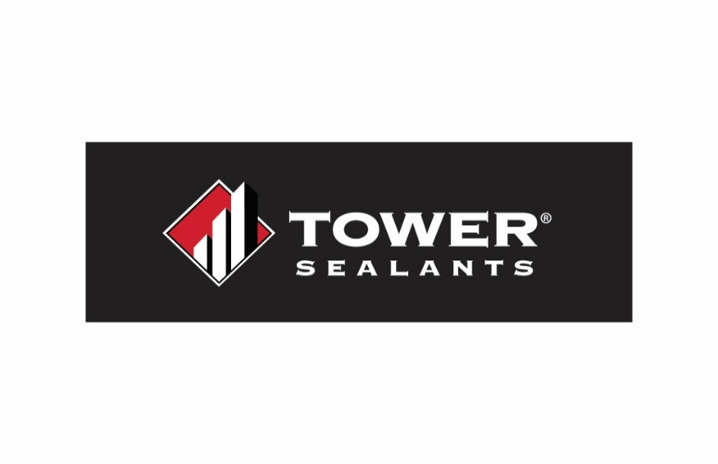
Technical Data Sheet
AU-1 LAB
Liquid-Applied Air, Water, and Flashing Barrier
Product Specifications

Vehicle: 100% Styrene Butadiene Resin
VOC: Non-chemically curing membrane. VOC (less water and exempt compounds) <50 g/L (SCAQMD)
Pigment: Calcium Carbonate
Weights Solids: Approximately 66.42%
Volume Solids: Approximately 53.0%
Weight per Gallon: 11.11 ± 0.5
Specific Gravity: Approximately 1.33
Service Temp: -30ºF to 180ºF
Temp Application
Range: 40ºF and rising. Air temp no hotter than 95ºF and substrate not hotter than 160ºF
Freeze Thaw Stability: Passes 5 Cycles@ 0ºF
(1 cycle = 16hrs. @ 0ºF, 8hrs at 75ºF)
Flash Point: N. A.
Consistency: Paste / brush-able
Applications: Interior / Exterior
Life Expectancy: 60-year performance
Shelf Life: 18 months when stored at 50ºF to 80ºF
Odor: Mild Acrylic
Tooling Time: 10 to 20 Minutes
Tack Free Time: 60 Minutes
Topcoat Time: 6 to 8 hours @ 75°F and 50% Humidity
Full Cure: 24 to 72 hours

Product Description:
AU-1 LAB is a high performance, single component, Styrene Butadiene Resin (SBR) elastomeric liquid weather resistive barrier and flashing membrane. This weather resistant barrier (WRB) functions as both a membrane and flashing and is designed to protect structures from moisture intrusion, air leakage, and environmental stressors. This low-odor, waterproofing barrier can be sprayed, brushed, or rolled, and requires no primer. It is formulated to provide a permanent, breathable waterproof seal with excellent adhesion to most common substrates, including green concrete. It is low VOC, easy to apply, and is easy to clean with soap & water. AU-1 LAB can be used on rough openings, around penetrations and on broad wall applications as a weather-resistive barrier.

Performance Features:
- Tested in accordance with performance requirements of ABAA for weather-resistive barrier materials
- Meets the performance requirements of AAMA 714-22 & 714-19
- Provides a breathable, waterproof seal
- No isocyanates or phthalates
- UV, mildew and weather resistant once cured
- Soap & water cleanup
- Resistant to tearing
- May be exposed to weather for up to 6 months without degrading performance characteristics
- Outstanding adhesion
- Paintable
- Can be applied to green concrete
- Apply by brush, sprayer, or roller
- 18-month shelf life
Packaging: 5 US Gallon
Color: Blue
Item Number: TS-00462
UPC Code: 843034004626

Compatible Substrates:
Masonry Aluminum Wood
Concrete Brick Vinyl
Exterior Gypsum Building Envelope Systems
OSB/Plywood Sheathing Stucco
Packaging: 1 US Gallon
Color: Blue
Item Number: TS-00461
UPC Code: 843034004619

Compatible Systems:
Stucco EIFS Foamboard
Exterior Cladding Systems Housewraps
Compatible with most coatings and sealants
AU-1 LAB (cont.)

Surface Preparation:
Surfaces to be free of all dirt, dust, oil, mildew, frost or other contaminants. Any structural damage must be repaired prior to application. Any non-structural cracks or joints up to ½” should be sealed with AU-1 Elastomeric Construction Sealant prior to AU-1 LAB Application. Protect property and surface not to be applied with membrane.

Mixing:
Do not induce air if product needs to be mixed. Mix at slow speeds. Do not dilute product by adding water.

Application:
Use a brush, sprayer, or roller to apply AU-1 LAB to a minimum of 30 wet mils over the desired area of the rough opening including the exterior surface. Application should be done in a manner resulting in the membrane surface being free of openings or pinholes. AU-1 LAB may be applied up to 60 wet mils without sagging if required, due to substrate porosity. Backrolling is recommended after spray application. Allow product to skin before installing any components onto cladding or rough openings. Skin times may vary by humidity and conditions. Check local building codes for additional recommendations or requirements.

NOT INTENDED FOR AREAS THAT WILL BE SUBMERGED IN WATER. KEEP FROM FREEZING. NOT FOR FOOD CONTACT SURFACES. PRODUCT CANNOT BE SANDED.

Spray Equipment:
AU-1 LAB is compatible with most airless spray equipment manufacturers.
- Recommended tip orifice size: .021 - .025
- Recommended pressure: 3000 PSI
- Recommended GPM (gallons per minute): 1.15 - 2.5
Additional details available in AU-1 LAB Installation Guide

Coverage:
Approximately 50 sq ft per gallon to achieve 30 wet mil. Coverage will vary greatly depending on porosity of substrate and application method.

Clean Up:
Immediately after use, clean uncured material and tools with soap and water. Remove cured membrane by cutting with a sharp-edged tool.

Limitations:
Only apply AU-1 LAB when product, surface, and air temperatures are above 40° F and rising. Do not apply on surfaces exceeding 160° F. Do not apply to frozen substrates, prior to extreme weather, or before heavy rain. AU-1 LAB is not for use in below-grade applications, or in areas where frequent water ponding may occur. Product is not intended for use on surfaces where it will be permanently exposed.

Storage:
AU-1 LAB should be stored in original, unopened containers, away from heat and direct sunlight. Product should be kept from freezing. When stored correctly, product will have a shelf life of 18 months.

AU-1 LAB (cont.)

CERTIFICATION & TESTING
ABAA Air Barrier Association of America Compliance Testing:
Property | Value | Test Method
Water Vapor Permeance  - Desiccant Method | 0.0000840716 (Perm, Inch-pound) | ASTM E-96
Water Vapor Permeance  - Desiccant Method | 0.0000049087 (Perm, inch) | ASTM E-96
Water Vapor Permeance  - Water Method | 0.001068777 (Perm, Inch-pound) | ASTM E-96
Water Vapor Permeance  - Water Method | 0.0000445324 (Perm, inch) | ASTM E-96
Average Air Permeance @ 75 Pa | 0.00077084 L/(Pa.m2.s), PASS | ASTM E2178-21a
Pull-Off Adhesion | 346.4 (psi), PASS | ASTM D4541
Flame Spread Index (FSI) | 10, Class A | ASTM E84
Smoke Developed Index (SDI) | 35, Class A | ASTM E84
Water Resistance | PASS (3 out of 3 no failures) | AATCC 127
Water Absorption | 17% | ASTM D471
Sag | 60 (mils) | ASTM D4400-18 sag (mils)
Crack Bridging | PASS (5 out of 5 no failures) | ASTM C1305
Nail Sealability | PASS (4 out of 4 no failures) | ASTM D1970
AAMA 714-22: Liquid-Applied Flashing Testing:
Property | Value | Test Method
Adhesive Bond to Substrates (5.1) | PASS Cement & Plywood | ASTM C-794
Water Penetration Around Nails (5.2) | PASS | AAMA 711 section 5.2
Accelerated UV aging (14 Days) Peel Adhesion (5.3) | PASS (Cement) | ASTM G154 Cycle 1 or G155 / ASTM C-794
Elevated Temperature Peel Adhesion (5.4) | PASS (Cement & Plywood) | ASTM C-794 / AAMA 711, Section 5.5
Thermal Cycling Peel Adhesion (5.5) | PASS (Cement) | AAMA 711, section 5.6.3 / ASTM C-794
Crack Bridging Ability (5.6) | PASS Category 1 & 2 | ASTM C1305 modified as in section 5.6 of AAMA 714-19
Water Immersion Peel Adhesion (5.7) | PASS (cement) | AAMA 711 section5.8
Water Vapor Permeability (6.3) | PASS, 13 perms | ASTM E-96

AU-1 LAB (cont.)

WARNING! IRRITATING TO SKIN, EYES AND RESPIRATORY TRACT. Harmful if swallowed, inhaled or absorbed through the skin. May cause allergic skin reactions and/or central nervous system depression. Adverse reproduction effects have been reported in animals. May cause adverse kidney effects. Avoid contact with eyes, skin and clothing. Use in well ventilated area. Wear eye, skin, and respiratory protection. Eye contact: Immediately flush with water for 15 minutes and get medical attention immediately. If swallowed: Do not induce vomiting. Give large quantities of water and get medical attention. Never give anything by mouth to an unconscious person. For health information, refer to Material Safety Data Sheet or call Chemtrec at 800-424-9300. KEEP OUT OF REACH OF CHILDREN.
⚠️ WARNING! This product can expose you to chemicals, including petroleum distillates, which is known to the State of California to cause birth defects, reproductive harm, and/or cancer. For more information, visit www.P65Warnings.ca.gov.

Material Safety Data Sheets (SDS) available upon request via towersealants.com or by calling 866-897-7568
Warranty: TOWER Sealants warrants this product to be free from manufacturing defects. The installer is responsible for the testing of this product on the surfaces of the targeted application for compatibility and performance prior to use. This is the sole and exclusive remedy and liability for defects or failure of this product. THIS WARRANTY IS IN LIEU OF ALL OTHER WARRANTIES, WRITTEN OR ORAL, STATUTORY, EXPRESSED OR IMPLIED; INCLUDING WITHOUT LIMITATION ANY IMPLIED WARRANTY OF MERCHANTABILITY OR FITNESS.

